Bucharest Polytechnic University

Faculty of Engineering in Foreign Languages

May 2018

**Operating Systems Project:**

**MICROSOFT PAINT**

**Bratucu Ana Maria**

**Matei Cristina**

**Group 1221**

**Contents**

1. Introduction........................................................................................................................... 3

2. Implementation …................................................................................................................. 4

3. Architecture........................................................................................................................... 5

3.1 GUI ………………………………………………………………………………..5

3.2 Unified Modeling Language (UML) diagram……………………………………..7

4. User’s Guide ........................................................................................................................10

4.1 Installation……………………………………………………………………….10

4.2 How to use it……………………………………………………………………..11

4.3 Desinstalation……………………………………………………………………13

5. Conclusion ....................................................................................................................…...14

5.1 Further developments…………………………………………………………….14

5.2 Comparison with other applications……………………………………………..15

6. References ...........................................................................................................................15

1. **Introduction**

**Paint** (formerly **Paintbrush**), commonly known as **Microsoft Paint** or **mspaint**, is a simple [graphics editor](https://en.wikipedia.org/wiki/Raster_graphics_editor), a tool used to draw, that has been included with all versions of [Microsoft Windows](https://en.wikipedia.org/wiki/Microsoft_Windows). It is a simple, faster graphics editor that has been included with all versions of Microsoft Windows. The program opens and saves files in [Windows bitmap](https://en.wikipedia.org/wiki/Windows_bitmap) (BMP), [JPEG](https://en.wikipedia.org/wiki/JPEG), [GIF](https://en.wikipedia.org/wiki/Graphics_Interchange_Format), [PNG](https://en.wikipedia.org/wiki/Portable_Network_Graphics), and single-page [TIFF](https://en.wikipedia.org/wiki/TIFF) formats. The program can be in color mode or two-color [black-and-white](https://en.wikipedia.org/wiki/Black-and-white), but there is no [grayscale](https://en.wikipedia.org/wiki/Grayscale" \o "Grayscale) mode. For its simplicity, it rapidly became one of the most used applications in the early versions of Windows, introducing many to painting on a computer for the first time. It is still widely used for simple image manipulation tasks. It allows access to virtual painting experiences from which people were previously limited with only paper and pencil.

Paint can enable ‘painting’ by dragging the mouse and using different types of artistic brushes or pens that can give for example a watercolour or oil effect. The paint also ‘runs out’ on certain brushes after a period of time so that the brush needs to be put back into the colour again, as if it was a real painting brush.

Many complex graphics software applications have concepts that are included in Microsoft Paint and the same principals can be applied in these from learning within Microsoft Paint.

We propose this subject of a drawing application where the user can create different sketches using several tools like: pen, brush, shapes (line, rectangle and ellipse) and colors. There are a few displayed colors, but also an entire palette from where we can choose a lot more. There are two types of shapes that can be drawn: the outline (border) of the shapes (empty inside) and full-colored shapes. The size (thickness) of the lines can be adjusted from our four options of line sizes buttons, therefore, the drawing possibilities are larger. The user can also attach an image from a folder and edit it, then save their work onto their computers. After all this, the user can erase everything from the canvas and start with a new page. If something goes wrong, the user has at his disposal a useful tool, the eraser. And, of course, the exit button which closes the application, but not before asking if the progress wants to be saved. If not, the application closes without any further operations. Therefore, our Paint application contains the most important parts of any drawing application: tools, shapes, colors and useful operations to handle the application.

## The purpose of the project is to help people create virtual drawings. And we chose the Paint Application because it is the most accessible program on the planet, that makes it is available on almost every computer in the world. On the other hand, Paint has its limitations, but they are what make it so special. Working with such limited tools and basic software makes you really push yourself creatively. It’s a great place to start drawing or, in other

## cases, a great place to build your artistic style. This painting program will taught you the value of simplicity. The tools in the program play a huge part in making your drawings look more complex.

## 

## Implementation

## For implementation we used C# programming language because it is an elegant and type-safe object-oriented language that enables developers to build a variety of secure and robust applications that run on the .NET Framework and it allows tools to make it easier to develop Windows client applications. The code was developed in Microsoft Visual Studio IDE, Windows Forms App (.NET Framework), using the benefits of this compiler because you'll often profit from tools with more code understanding than just blocks of text. Visual Studio Code includes built-in support for

## IntelliSense code completion, rich semantic code understanding and navigation, and code refactoring. Visual Studio can run, and therefore, is available to download on multiple Operating Systems like Windows, Linux and Mac OS.

## 

## Architecture

## Graphic user interface

## The application can create different sketches using several tools like: pen, brush, shapes (line, rectangle and ellipse) and colors. There are a few displayed colors, but also an entire palette from where we can choose a lot more. There are two types of shapes that can be drawn: the outline (border) of the shapes (empty inside) and full-colored shapes. The size (thickness) of the lines can be adjusted from our four options of line sizes buttons, therefore, the drawing possibilities are larger. The user can also attach an image from a folder and edit it, then save their work onto their computers. After all this, the user can erase everything from the canvas and start with a new page. If something goes wrong, the user has at his disposal a useful tool, the eraser. And, of course, the exit button which closes the application, but not before asking if the progress wants to be saved. If not, the application closes without any further operations.

## 

OurPaint App contains two classes: MainForm and Program**.** In the first class we use every method that helps us run the application. After we initialize the variables, we have the MainForm(), that initialize the components for the Paint application. After that, we have the methods applied to our buttons or events:

* The functions that set the colors for every single color button (these buttons are used to change the line border or filling color to the given syntax color): void BlackClick, void DarkGrayClick, void BrownClick, void GrayClick, void MaroonClick, void RedClick, void WhiteClick, void PinkClick, void YellowClick, void OrangeRedClick, void GoldClick, void LightSalmonClick, void GreenClick, void YellowGreenClick, void SteelBlueClick, void AquaClick, void MediumSlateBlueClick, void RoyalBlueClick, void PurpleClick, void BisqueClick;
* void CanvasMouseDown checks if the left button of the mouse was clicked, so if the canvas was clicked and if yes, we store the coordinates of the point we click;
* void CanvasMouseMove displays the mouse position on the screen and uses those coordinates to draw with pen, brush or erase everywhere the mouse is drawing; it also changes the size of the tool we draw with;
* void CanvasMouseUp checks if the mousedown variable, k, is false; in this case, that means that the user didn’t click on the canvas, so nothing happens;
* void MainFormLoad created the graphics for the canvas;
* void Button7Click, void Button8Click, void Button1Click, void Button3Click, void Button2Click, void Button4Click, void Button9Click, void Button10Click,

void Button11Click, void Button6Click, private void button13_Click, private void button14_Click assign a number of the figure, so we can use it to draw with a pen, brush, erase, draw a line, an ellipse, a rectangle

* void CanvasMouseClick checks if mouse is clicked and if yes, it allows to draw a line, an ellipse (border or filled) and a rectangle (border or filled);
* void Button5Click sends a message box to assure the user wants to delete everything from the canvas and if yes, sets the image to null, so it refreshes;
* void SaveClick checks if the file we want to save doesn’t already exist in the destination folder and it saves the file there with the wanted extension;
* void OpenClick opens an image file by calling the OpenFileDialog;
* private void button15_Click performs the same code as for the save file button because it closes the application, but before that, it asks the user if they want their drawing saved and if yes, it saves it;
* void Button12Click allows the user to edit and create custom colors using the color dialog;
  1. **UML (Unified Modeling Language) diagram**
* **in Visual Studio:**

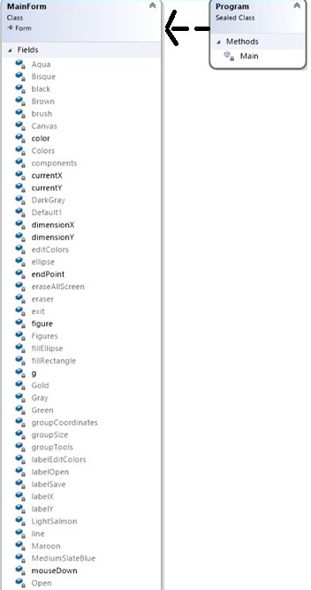

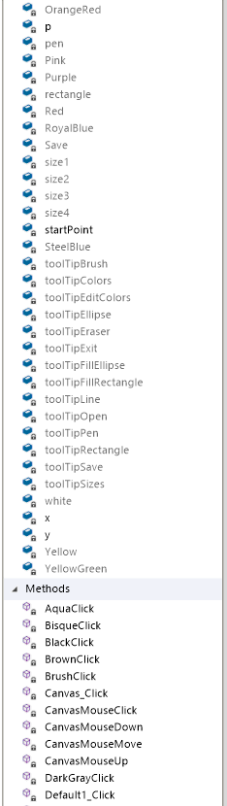

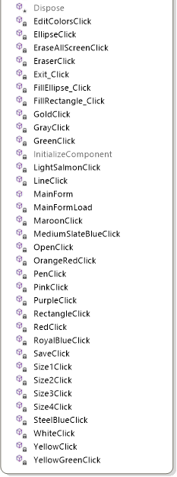

* **Our UML diagram:**

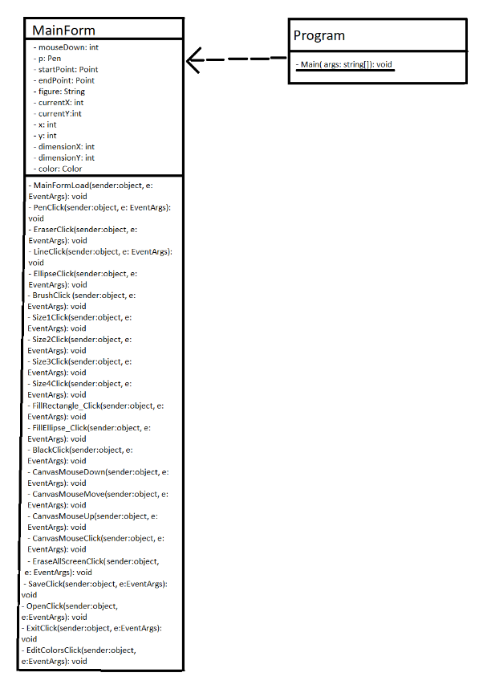

1. **User Guide**

**4.1 Installation**

The software needs to install this application are: a computer with at least 3 KB free and Windows 8 or more.

For installation, we generated an executable file called setup.exe using Visual Studio. For that we used .NET, version 6.4. After you download the file, you enter the Paint folder/Setup1/ Debug and there you will find setup.exe and double click it. Then, there are only a few steps someone has to follow in order for the installation to be complete.

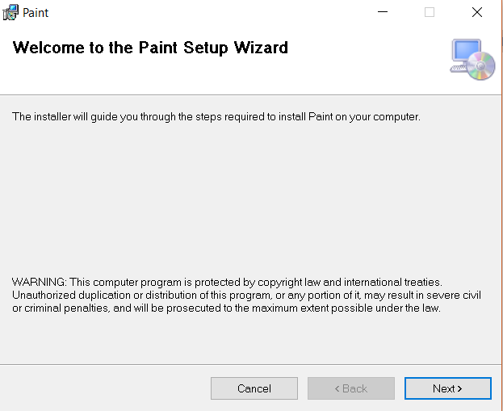

The user has the allow access to the application and then they will find a shortcut of the application on their desktop. They can view it by double clicking it. The process is very simple for everyone to execute and largely accessible.

**4.2 How to use it**

When the Paint application first opens, the user will see a blank canvas and in the upper part of the window, some tools. Each tool does a different thing, each one having a specific icon picture in order to realize what you are selecting. But for further information, each button has its own tool tip. So when you hover the button, a text will appear signalling what tool there is. These help to find everything much faster.

All our drawing features consist of:

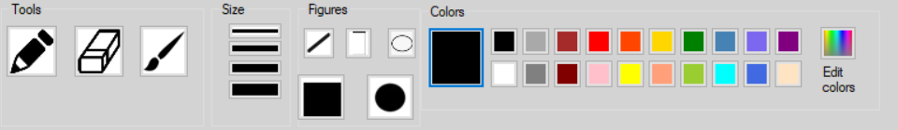

Tools like Pen, Brush and Eraser

4 types of sizes

Figures such as line, border ellipse, border rectangle, filled ellipse and filled rectangle

And a broad palette of colors.

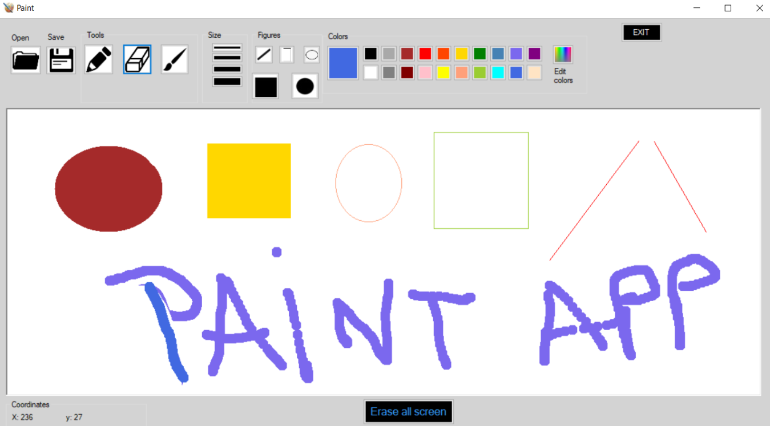

Other important parts from our application is the fact that the user can open an existing picture from their personal computer into our application and edit it.

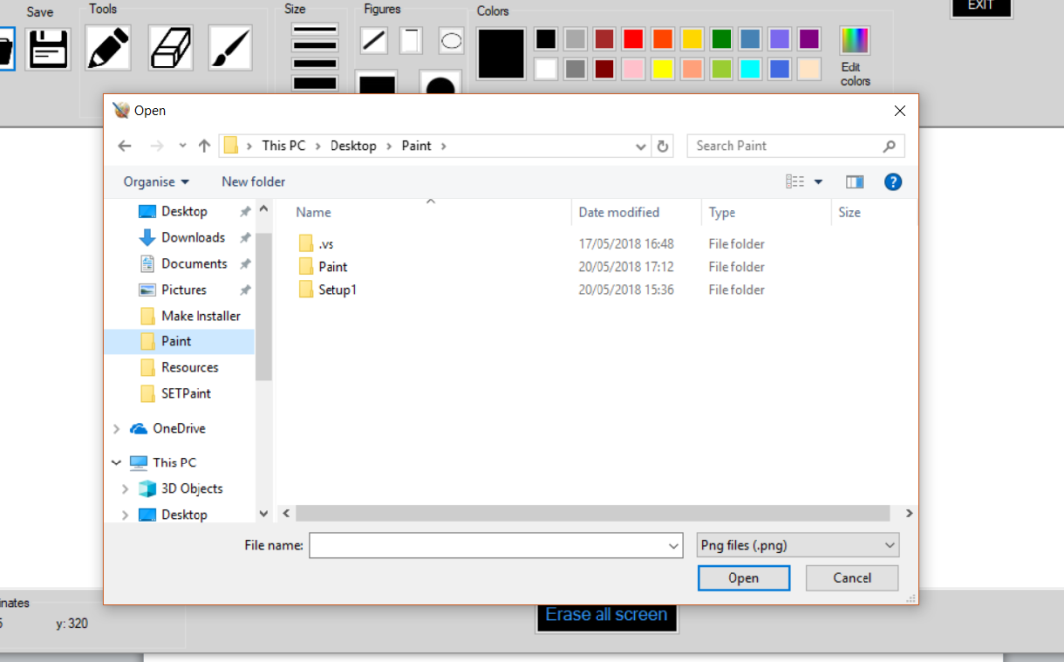

Or save their work.

If the user wants to clear the canvas and start a new drawing, they can click on the “Erase all screen” button from the bottom of the page. In order to avoid losing the drawing by accidentally clicking on this button, we put an alert message that asks the use if they really want to erase the canvas.

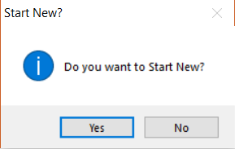

For the same reason, that box also appears when they press the exit button from the top right part of the application.

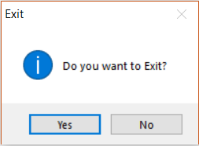

If the answer is Yes, the user will be welcomed by a window asking if they want to save what they drew.

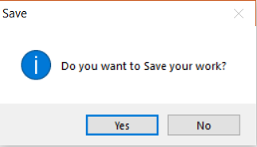

**4.3 Desinstalation**

When the user wants to uninstall the program, that can be done very simple. There are two ways to do it. The first one is from our executable file setup.exe that we used to install it. You enter the Paint folder/Setup1/ Debug and there you will find setup.exe and double click on it, a window will appear. We select the option Remove and click Finish. After waiting for a few moments, you will be announced that the application was removed.

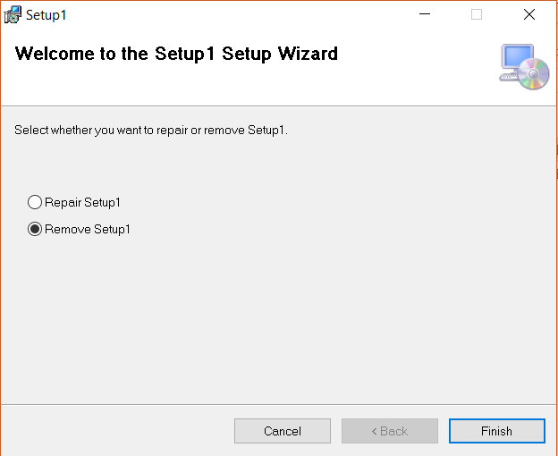

The second option to uninstall is to open Control Panel, double click on Add Remove Programs, search for OurPaint App in that list. When you find it, click on it and click Uninstall. Wait a few seconds and it will be removed.

1. **Conclusions**

We come with a basic, easy-to-use image creation program called OurPaint, a drawing application allows users to use draw, paint and editing basic image features without having to use advanced and expensive software like Photoshop.

**5.1** **Comparison with other applications**

Our applications had the source of inspiration the Microsoft integrated application Paint and they have a lot of features in common. OurPaint does not have all the options and features found in many image editing programs. Photoshop and Paintshop, for example, have a variety of filters, brushes and robust editing tools in their toolboxes. OurPaint does not support transparency, filters or layers. It only allows users to draw over images, save them and erase parts of them. The program has a small set of brushes, pens and other drawing tools. However, sometimes these features are sufficient to perform basic image manipulation. The program supports many popular image formats, such as JPEGs and PNGs.

**5.2 Further developments**

In addition to our current version, in the future we would like to improve the application by adding many more elements such as text boxes, rotate a selected area, crop the picture or drawing and the zoom magnifier setting. This way, we can compete with the Microsoft application and give it to the world to enjoy.

1. **References**

* **https://en.wikipedia.org/wiki/Microsoft_Paint**
* **https://msdn.microsoft.com**
* **https://www.youtube.com/watch?v=JpqQVpFfFN8&feature=youtu.be**
* **https://www.digitalunite.com/guides/microsoft-programs/what-microsoft-paint**